**How To Run The Collection In Command Prompt**

* Install Node JS 🡪 Search on Google “Node JS Download”.
* Download the .msi file.
* Install Node JS.
* Open Command Prompt 🡪npm -v & node -v
* Install New Man 🡪 npm install -g newman
* Export The collection From Postman

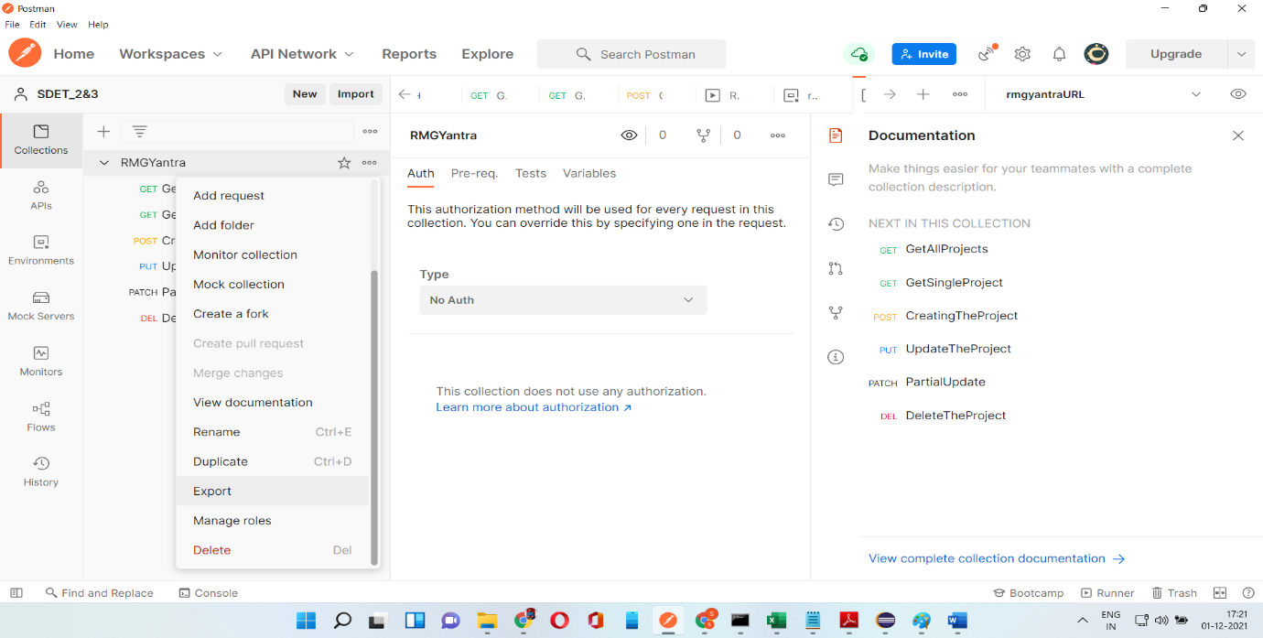

* Save The file with .json
* If Environment Variable is there then Export those with .json

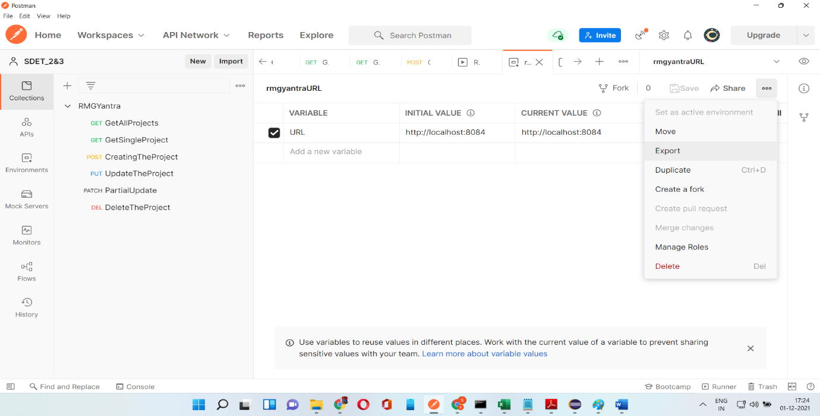

* Type the command in command prompt

newman run <collection Path> -e <Environment Variable Path>